
You are Invited
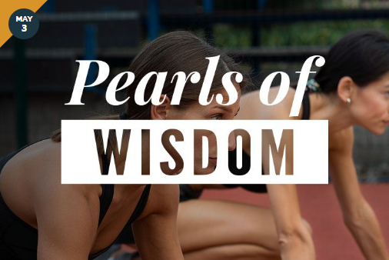
Pearls of Wisdom Breakfast
Raising the Game
Friday, May 3, 2024
8:00 – 10:00 am
AdventHealth Training Center
One Buccaneer Place
Tampa, FL 33607

Panelists:




Tara Battiato Andrea Murphy Denise Schilte-Brown
Tampa Bay Buccaneers Vinik Sports Group Tampa Bay Sun FC
Representatives from the Tampa Bay Rays to be announced!
Please join us for a dynamic panel discussion as we revolutionize the sports dialogue. Hear from influential female leaders in the Tampa Bay sports scene as they share insights on elevating women in athletics.
From amplifying women’s sports across the region to expanding one’s knowledge of the sports landscape, we're igniting change and celebrating Champa Bay’s vibrant sports community. Don't miss this chance to be at the forefront of the conversation, propelling women in sports to unprecedented levels of success.
RSVP
Greenberg Traurig, PA | Attorneys at Law | www.gtlaw.com

